

KENYA SCHOOL OF LAW
CLASS C FIRM 10
ATP 107: CONVEYANCING
ASSIGNMENT 1
COURSE INSTRUCTOR: MR.KIBET SANG

QUESTION:

Upon giving the outline of the conveyancing cycle in brief, discuss the pre-contract stage, noting to generate a client interview checklist and client instructions note/template.

LIST OF MEMBERS

NO. | NAME | ADMISSION NUMBER
1. | OGOTI CYNTHIA MWANGO | 20240523
2. | CHIWAYA NYAMAWI JULIUS | 20240499
3. | WAITHAKA RICHARD GATITU | 20240494
4. | ESTHER WANGARI MAINA | 20240495
5. | ZITAH MWENDE NKONGE | 20240493
6. | WINNIE KAGWIRIA MUTHUURI | 20241753
7. | ABDULBASIT AHMED ADAN | 20240290
8. | BRIAN FELIX ODERO | 20240749
9 | KIMUTAI EMMANUEL | 20241263

CONVEYANCING CYCLE
The conveyancing process will generally involve 5 stages:
a) Pre contract
b) Contract
c) Post contract/pre closing
d) Closing/completion
e) Post closing/completion.

PRE-CONTRACT STAGE
During the pre-contract stage, preliminary inquiries relating more to the physical condition of and location of the subject property as well as the proposed contractual document itself are made.
Whether it be initiating conveyancing law or delivering the completion documents, it is very important for an advocate to take the client’s instructions well and to act on them to the best of his ability.
THE INITIAL CLIENT INTERVIEW
With conveyancing, it is crucial for the advocate in question to ask the important questions to their client.
Good interviewing techniques are important in a full understanding of the facts in the transaction and enables the advocate to properly advise their client, investigate the title and draft the conveyancing document(s). Much of the success in these duties depends on the level of interaction with the client.
The advocate themselves must ensure that they are indeed qualified in taking up the brief in question. Section 34 (1) (a) of the Advocates act states that no unqualified person shall either directly or indirectly take instructions or prepare documents on conveyancing matters. Moreover, the advocate must possess a current and valid Practicing Certificate, failure to which will be an act of professional misconduct.
IMPORTANT DATA TO BE COLLECTED
- Details of parties: their names, their capacities (minor or adult), interest in property (whether leasehold or freehold)
- Details of property and proposed conveyance e.g.: parcel umber, any fixtures, the consideration etc.
- Authorization to disclose details and information about the transactions to other members in the chain. This is important to dispense with the duty of confidentiality. (As discussed in the case Mortgage Express Investments v Bowerman and Partners, whereby a solicitor was working on behalf of both a lender and a borrower and attained important information that he failed to disclose. It was held that he had a duty of care to disclose the information to both parties, thus working under the two arose a conflict of interest)
- Details on pre-contract responsibilities such as consents and clearance rates (if acting for the vendor/seller)
- Details of financing, deposit, stamp duty, undertakings etc. (if acting for the purchaser)
- Details on title documents (ensure to obtain copies)
- Discuss issues of conflict of interest if acting for both parties with their consent. (As held in the case King Woolen Mills v M/S Kaplan and Stratton Advocates whereby the firm had acted for both the borrower and lender in a borrowing transaction and prepared all the security documents. However, the borrower defaulted on repayment and questioned the validity of the security documents prepared. The Court of appeal upon hearing the case asserted that; given the firm prepared the documents, it was aware that there was likely to arise a conflict between the parties and having acted for both parties, were privy to information pertaining to the case. As such, the firm could not enforce the securities as it would be prejudicial to the appellant’s case. It was therefore held that, an advocate is not supposed to work for both the vendor and purchaser and if they do, they have a duty to disclose the same)
- Discuss issues of fee chargeable (must be confirmed in writing at the start of the conveyancing transaction)

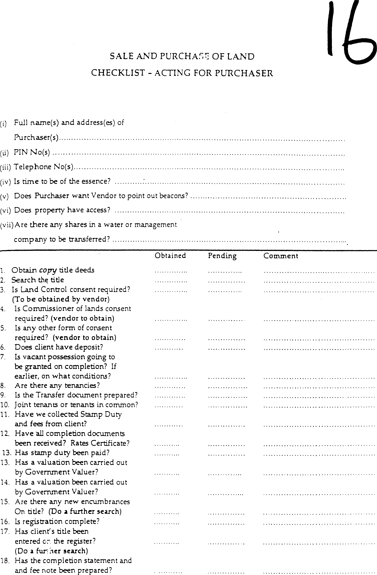

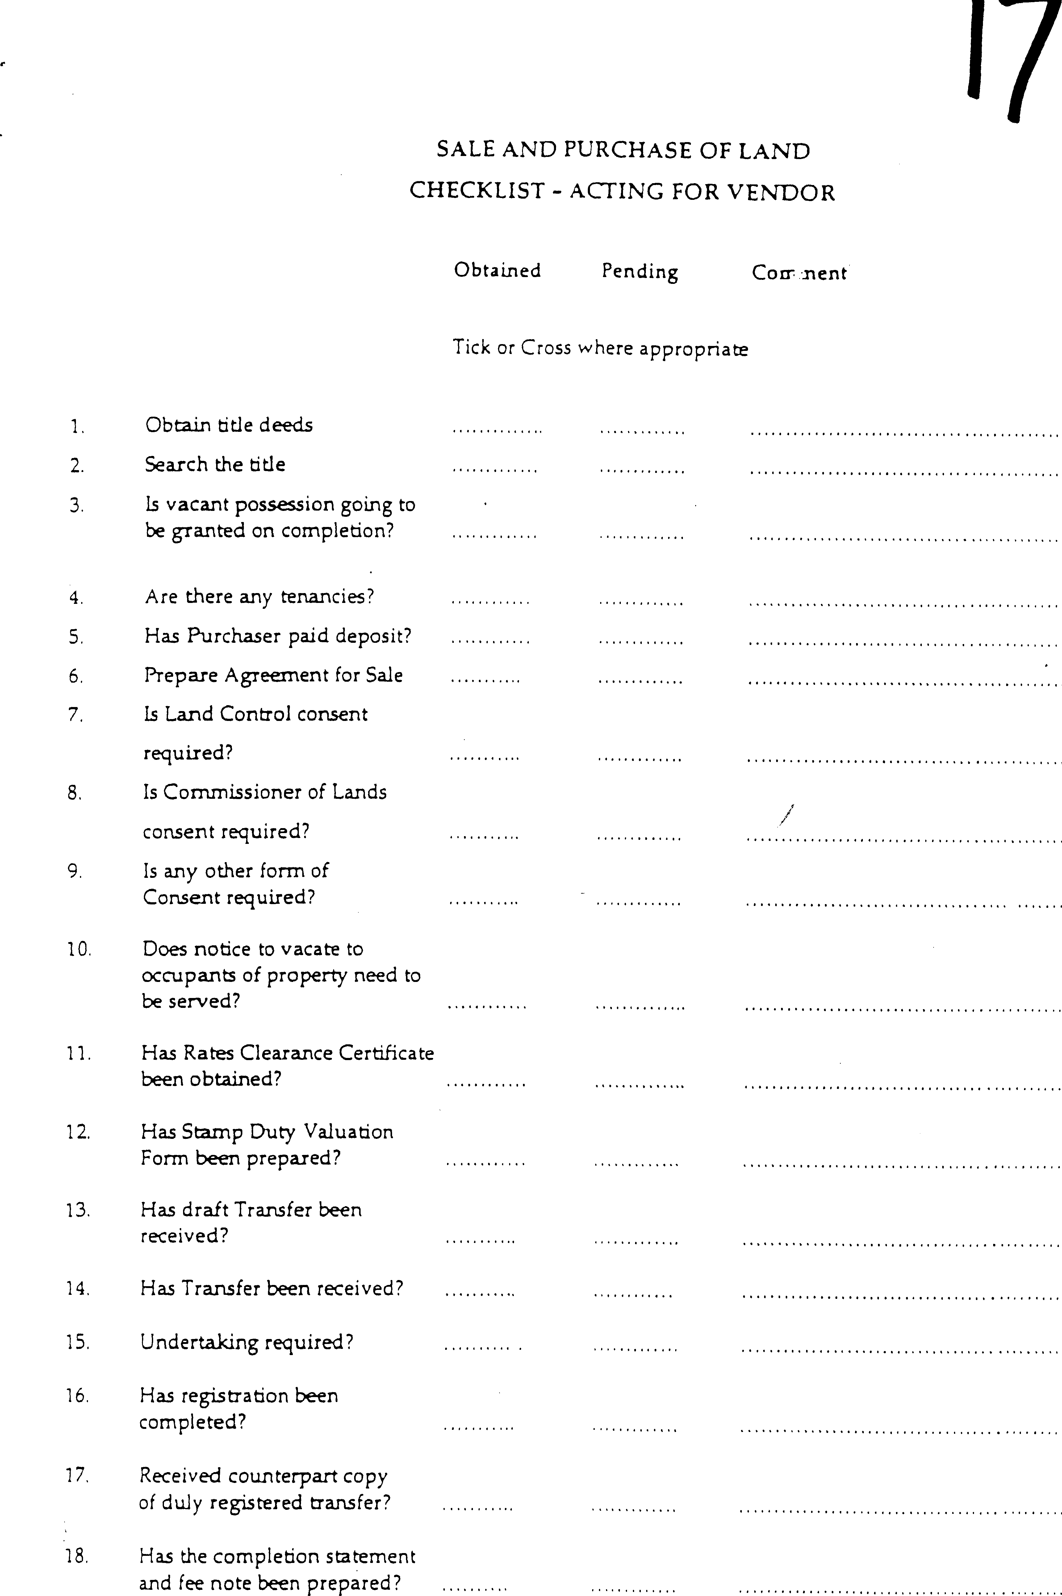

INSTRUCTIONS NOTE

TRANSFER OF XYZ PROPERTY

I JNC confirm that I have instructed and authorized MCW advocates P.O box 25-00100 Nairobi to act for me and represent me in connection with the above matter.

DETAILS OF THE PARTIES
Date of Transfer
Transferor(s) | ^{Give full name(s)}
ID/Passport/Company Registration No.
Transferee(s) | ^{Give full name}
ID/Passport/Company Registration No.

Consideration | **Amount of: .......................
Nature of interest to be transferred

Dated at…………………. this………………day of …….2024

NAME: ……………………………………
ID NO………………………………………
SIGNATURE………………………………
PHONE NUMBER…………………………

WITNESS…………………………….
ID NO…………………………………
SIGNATURE…………………………

Section 34 Advocates Act, Chapter 16 Revised Edition 2012 [1989]
Mortgage Express Ltd v Bowerman & Partners [1996] 2 All ER 836
King Woolen Mills and Another v. Kaplan and Stratton Advocates Nairobi Civil. Appeal No. 55 of 1993 eKLR

